# Smile Survey Screener Payment/Invoicing Information

**Steps for Vendor Account Set-up:**

1. Fill out the W-9 and ACH form.
2. Submit your information to this [link](https://app.smartsheet.com/b/form/8f5ad10dfdaa4d9e84ba91299cfe9193).

**Steps for invoicing travel and calibration expenses:**

1. Your travel costs plus $360 will be covered for attending the Smile Survey Calibration Training on 10/28/22.
2. Fill out the provided expense form. For travel, include your mileage or plane fare and per diem amounts as applicable.

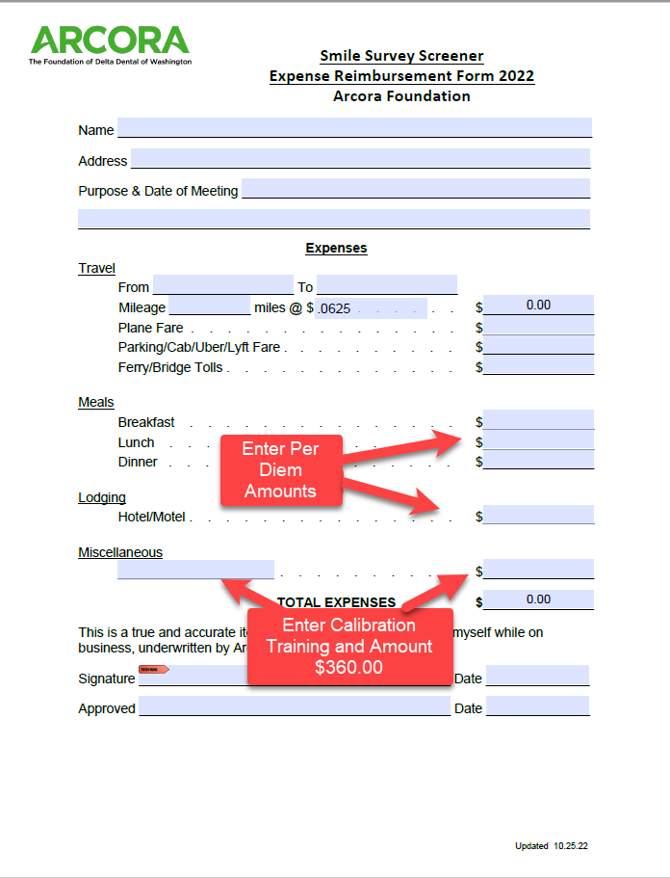

**Steps for invoicing school screenings**

1. Use the provided invoice template and fil-in the following fields
   1. Name and address
   2. Current date
   3. Add an invoice number, it must be different for each submitted invoice
   4. Add date screened, screened, school name and payment amount for the school site.
2. Go to this link and submit invoice.
   1. [**https://app.smartsheet.com/b/form/9c25975ac3c64111a60ba388d3e794c7**](https://app.smartsheet.com/b/form/9c25975ac3c64111a60ba388d3e794c7)

